Style Guide for Python Code

Revision History

Revision # | Author | Reviewed By | A. Description Of Change  B. Summary of Review | Issued by / Date (mm/dd/yy)
0.1 (draft) | Chenjin | . | Initial Draft | 09.09.2010

Table of Contents
1. Introduction 4
1.1 Purpose 4
1.2 Scope 4
2. code lay-out 4
2.1 Indentation 4
2.2 Maximum Line Length 4
2.3 Blank Lines(option) 4
2.4 Encodings(option) 4
3. Imports(mandatory) 5
3.1 Imports should usually be on separate lines 5
3.2 Imports location and order 5
4. Whitespace in Expressions and Statemens（mandatory） 5
4.1 Avoid extraneous whitespace in the following situations 5
4.2 Other Recommendations 6
5. comments(option) 7
5.1 Block Comments 7
5.2 Inline Comments 7
6. Documentation strings（mandatory） 7
6.1 Docstrings for public methods 7
7. Naming Convention（mandatory） 8
7.1 Naming stytle 8
7.2 Names to Avoid 8
7.3 Package and Module Names 8
7.4 Class Names 8
7.5 Exception Names 8
7.6 Global Variable Names 9
7.7 Function Names 9
7.8 Function and method arguments 9
7.9 Method Names and Instance Variables 9
7.10 Constants 9

Introduction

Purpose
This document gives coding conventions for the Python code for our TA library.

Scope
This document is an internal manual intend for TD-LTE I&V TA.

code lay-out

Indentation
Use 4 spaces per indentation level.

Maximum Line Length
Limit all lines to a maximum of 79 characters.

Blank Lines(option)
Separate top-lsevel function and class definitions with two blank lines.
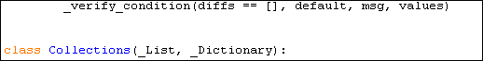

Method definitions inside a class are separated by a single blank line.
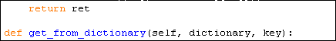

Use blank lines in functions, sparingly, to indicate logical sections.
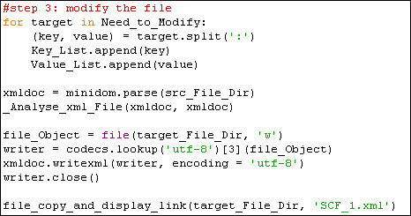

Encodings(option)
Add “#-*- coding:utf-8 -*-” in your top file

Imports(mandatory)

Imports should usually be on separate lines
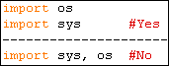

It's okay to say this though:

Imports location and order
Imports are always put at the top of the file, just after any module comments and docstrings, and before module globals and constants.

Imports should be grouped in the following order:
- standard library imports
- related third party impots
- local application/library specific imports
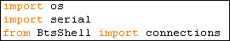

Whitespace in Expressions and Statemens（mandatory）

Avoid extraneous whitespace in the following situations
- Immediately inside parentheses, brackets or braces.

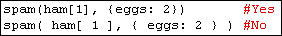

- Immediately before a comma, semicolon, or colon:

- Immediately before the open parenthesis that starts the argument list of a function call:

- Immediately before the open parenthesis that starts an indexing or slicing:
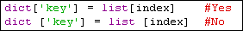

- More than one space around an assignment (or other) operator to align it with another.
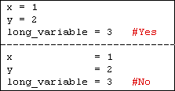

Other Recommendations
- Binary operators
Always surround these binary operators with a single space on either side: assignment (=), augmented assignment (+=, -= etc.), comparisons (==, <, >, !=, <>, <=, >=, in, not in, is, is not), Booleans (and, or, not).

- Arithmetic operators
Use spaces around arithmetic operators:
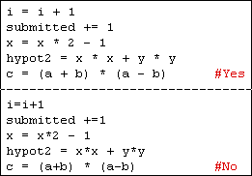

- default parameter value
Don't use spaces around the '=' sign when used to indicate a keyword argument or a default parameter value.
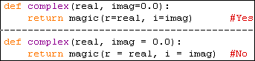

- Compound statements
Compound statements (multiple statements on the same line) are generally discouraged.
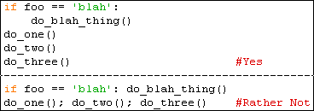

- Special circumstances
While sometimes it's okay to put an if/for/while with a small body on the same line, never do this for multi-clause statements. Also avoid folding such long lines!

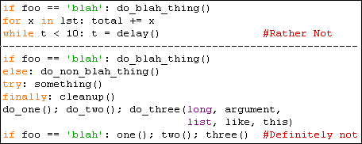

comments(option)

Block Comments
Block comments generally apply to some (or all) code that follows them, and are indented to the same level as that code. Each line of a block comment starts with a # and a single space (unless it is indented text inside the comment).

Inline Comments
Use inline comments sparingly.
An inline comment is a comment on the same line as a statement. Inline comments should be separated by at least two spaces from the statement. They should start with a # and a single space. Inline comments are unnecessary and in fact distracting if they state the obvious.
Don't do this:
But sometimes, this is useful:

Documentation strings（mandatory）

Docstrings for public methods
Write docstrings for all public modules, functions, classes, and methods. Docstrings are not necessary for non-public methods, but you should have a comment that describes what the method does. This comment should appear after the "def" line.
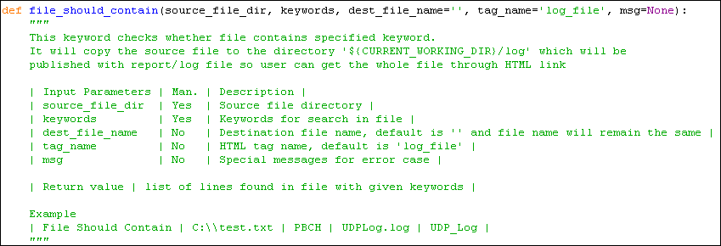

Naming Convention（mandatory）

Naming stytle
The following naming styles are commonly distinguished:
- b (single lowercase letter)
- B (single uppercase letter)
- lowercase
- lower_case_with_underscores
- UPPERCASE
- UPPER_CASE_WITH_UNDERSCORES
- CapitalizedWords (or CapWords, or CamelCase).
Note: When using abbreviations in CapWords, capitalize all the letters
of the abbreviation. Thus HTTPServerError is better than HttpServerError.
- mixedCase (differs from CapitalizedWords by initial lowercase character!)
- Capitalized_Words_With_Underscores (ugly!)

Names to Avoid
Never use the characters `l' (lowercase letter el), `O' (uppercase letter oh), or `I' (uppercase letter eye) as single character variable names.
In some fonts, these characters are indistinguishable from the numerals one and zero. When tempted to use `l', use `L' instead.

Package and Module Names
Modules should have short, all-lowercase names. Underscores can be used in the module name if it improves readability.
Python packages should also have short, all-lowercase names, although the use of underscores is discouraged.
Package name as follow:
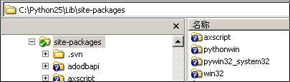

Module names as follow:
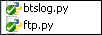

Class Names
Almost without exception, class names use the CapWords convention. Classes for internal use have a leading underscore in addition.

Exception Names
Because exceptions should be classes, the class naming convention applies here. However, you should use the suffix "Error" on your exception names (if the exception actually is an error).

Global Variable Names
The conventions are about the same as those for functions.

Function Names
Function names should be lowercase, with words separated by underscores as necessary to improve readability. mixedCase is allowed only in contexts where that's already the prevailing style (e.g. threading.py), to retain backwards compatibility.

Function and method arguments
Always use 'self' for the first argument to instance methods. 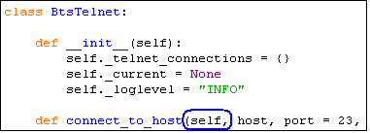
If a function argument's name clashes with a reserved keyword, it is generally better to append a single trailing underscore rather than use an abbreviation or spelling corruption.
Thus "print_" is better than "prnt".

Method Names and Instance Variables
Use the function naming rules: lowercase with words separated by underscores as necessary to improve readability.
Use one leading underscore only for non-public methods and instance variables.

Constants
Constants are usually declared on a module level and written in all capital letters with underscores separating words.
Examples include MAX_OVERFLOW and TOTAL.

